

QUALITY
MOMENTS
PHOTOGRAPHY

Professional Quality work, without the Professional price!

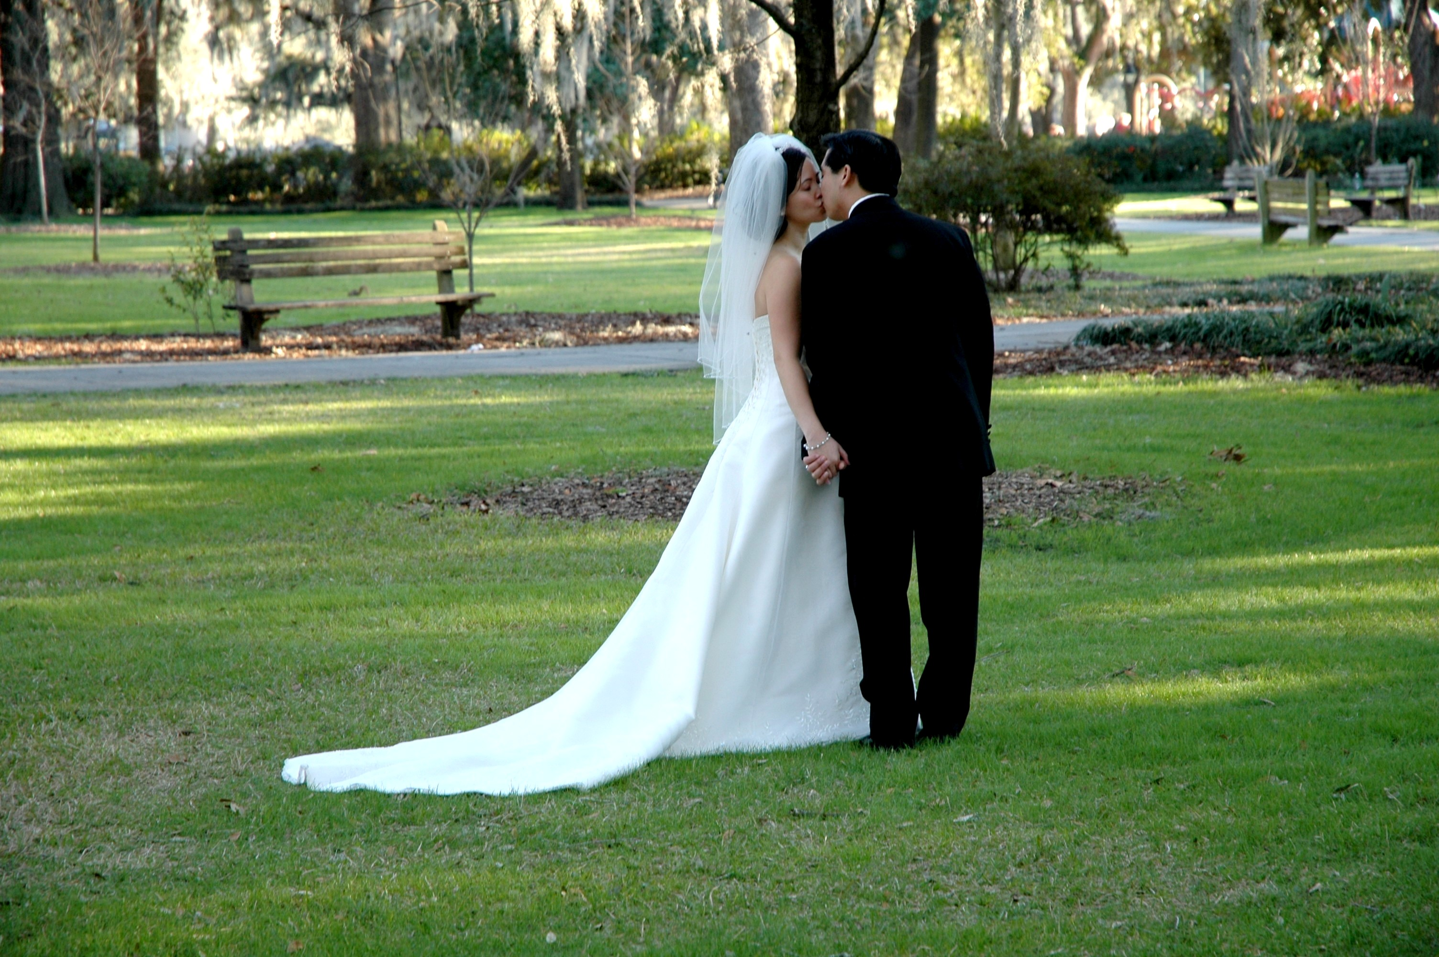
Kerry Thomas, Owner/Photographer
Phone: (912) 844-8600
e-mail me at kerrythms@yahoo.com
Call anytime for an appointment

Capturing precious moments with the highest level of quality and professionalism is our promise to you. When the moment MUST be captured perfectly, there’s a comfort in knowing that Quality Moments Photography has you covered.

QUALITY MOMENTS
PHOTOGRAPHY

Kerry Thomas, Owner/Photographer
Phone: (912) 844-8600

PRICE LIST
PACKAGE I
Includes 75 images placed a thumb drive with;
- ONE - 8x10
- ONE - 5x7
- Images will include photos of the wedding ceremony only
Reception is not included in this package.
*** 4 HOUR TIME LIMIT ***

PRICE: $700.00

PACKAGE II
Includes 90-145 images placed a thumb drive with;
- One - 5 x 7
      - Two - 8x10's

Images will include photos of the wedding ceremony and reception.
*** 4 HOUR TIME LIMIT ***
PRICE: $895.00

PRICE LIST

PACKAGE III

Includes 150-200 images placed a thumb drive with.

- Two - 5 x 7's
- Three - 8 x 10's
- One - 11 x 14

Images will include photos of the wedding ceremony, reception, before wedding shots, during wedding shots, and individual shots.
*** NO TIME LIMIT ***

PRICE: $ 970.00

PACKAGE IV

Includes 150 glossy or matt finished photos:

- 130 - 4x6's
- 4 - 5 x 7
- 6 - 8x10's
- 2 - 11 X 14
- 8 - WALLETS
- One photo album which includes ceremony and reception.
*** NO TIME LIMIT ***
PRICE: $1085.00

PACKAGE V

Includes 175 glossy or matt finished photos and
ALL PHOTO images placed a thumb drive

- 141 - 4 x 6's
- 6 - 5 x 7's
- 8 - 8 x 10's
- 3 - 11 x 14
- 1 - 16 X 20
- 16 - WALLETS
- 2 - PHOTO MUGS
- 1 - MOTHER-IN-LAW PHOTO ALBUM (75 – 4 X 6)
- - One photo album which includes photos of ceremony and reception. This includes before wedding shots, during wedding shots, after wedding shots and individual shots
*** NO TIME LIMIT ***
PRICE: $ 1725.00

